### **Project Idea: Recipe Finder**

#### **Why I Chose It:**

* **Personal Interest**: I love cooking and experimenting with new recipes, so a Recipe Finder is exciting and practical for me.
* **Challenge**: It balances creativity (UI/UX) and technical skills (API integration and data management).
* **Scalability**: This project has room for future enhancements, like filtering by cuisine, meal type, or diet preferences.

#### **API/ Dataset: Spoonacular API**

* **Why this API?**
  + Comprehensive recipe database.
  + Offers endpoints for searching recipes by ingredients, cuisine, or dietary restrictions.
  + Provides nutritional information, images, and cooking instructions.
* **API Features**:
  + **Search Recipes by Ingredients**: Lets users search for recipes using available ingredients.
  + **Recipe Details**: Fetches full details, including preparation steps and nutritional info.
  + **Nutritional Analysis**: Displays calories, macronutrients, etc., for each recipe.
* **API Docs**: Spoonacular API Documentation.

**Timeline**

| **Milestone** | **Tasks** | **Deadline** |
| --- | --- | --- |
| **Day 1: Idea & Research** | Choose ideas, finalize API, and set milestones. | Dec 23rd |
| **Day 2-3: Setup** | Install tools, create GitHub repo, and test the API. | Dec 24th and 25th |
| **Day 4: Version Control** | Practice using Git branches and pull requests. | Dec 26th |

**Development Environment Setup**

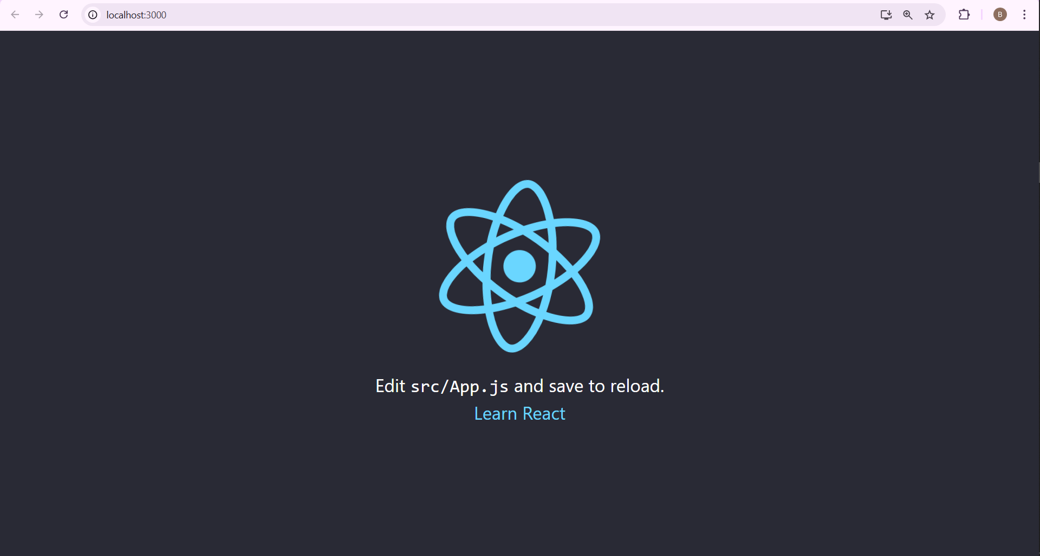

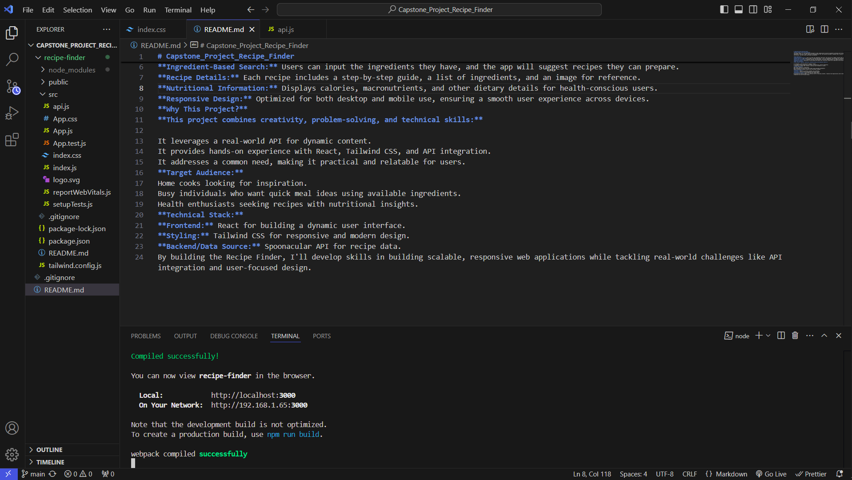

**Github link: https://github.com/P1pp3n/Capstone_Project_Recipe_Finder.git**